**“Within Limits IAM” (WILIAM): A new multiregional model integrating economic and biophysical dimensions to assess global future sustainability pathways**

UVA: David Álvarez-Antelo, Ignacio de Blas, Iñigo Capellán-Pérez, Margarita Mediavilla, Gonzalo Parrado-Hernando, Mohamed Lifi, Paola López-Muñoz, Luis Llases, Luis Javier Miguel González, Nathalie Wergles, Yania Crespo, Juan Campos, Laura Bartolomé, Daniel Pulido-Sánchez, Marta Calleja, Carlos de Castro, Gonzalo Manero, Fernando Frechoso

BC3: Iñaki Arto, Manuel Tomás, Ignacio Cazcarro

AEA: Lukas Eggler

CRES: Alexandros Adam, Stavroula Papagianni

CESAR: Kurt Kratena

INN: Ole van Allen

CARTIF: Noelia Ferreras, Iván Ramos

SDEWES: Luka Herc

FD.ID: Tomás Calheiros

UNIPI/UNIFI: Tiziano Distefano

**Summary**

Overview of the *Within Limits Integrated Assessment Model* (WILIAM), a new IAM designed to explore long-term decarbonization pathways within planetary boundaries by addressing a series of limitations of existing IAMs. WILIAM comprises 8 integrated modules of earth and human systems and focuses on the detailed representation of the economic processes and their consistent link with the biophysical sphere. It includes a rich portfolio of conventional and heterodox policies to simulate a broad range of narratives. This tool allows exploring the socioeconomic and environmental implications of long-term socio-ecological transition pathways', considering biophysical planetary limits as well as socio-economic constraints.

**Abstract**

In this presentation we will overview the *Within Limits Integrated Assessment Model* (WILIAM), a new open source IAM in its final stage of development within the [H2020 project LOCOMOTION](https://www.locomotion-h2020.eu/). WILIAM is a system dynamics policy-simulation model, descendent from MEDEAS [1], which has been designed to explore long-term decarbonization pathways within planetary boundaries by addressing a series of limitations of existing IAMs. In fact, despite the high number of IAMs, many share several relevant and disputable hypotheses/characteristics. The main shortcomings aimed to be addressed with WILIAM are: lack of plurality/simplified representation of economic processes typically based on optimization, equilibrium dynamics, aggregate production functions and representative agents [2, 3], future energy transitions modeled as demand-driven transformations (assumption of future high energy availability at affordable cost, both for renewables and non-renewables), the neglect of implications of future energy investments required to achieve the transition to renewables for the entire system (Energy Return on Energy Investment of the full system [4]), difficulties to reach 100% renewable systems, underestimation of the damages caused by climate change, the absence of the material dimension and key sustainability dimensions other than climate change.

WILIAM focuses on the detailed representation of the economic processes following a Dynamic Econometric Input-Output approach and consistently linking the economic and biophysical spheres according to the principles of Ecological Macroeconomics. WILIAM follows a complex system approach, in which the interactions between dimensions are more relevant than the complexity within each module. System dynamics allows to capture complex feedback loops and nonlinear relationships among social, economic, and environmental variables.

WILIAM comprises 8 integrated modules of earth and human systems: (1) demography, (2) society, (3) economy, (4) finance, (5) energy, (6) materials, (7) land and water, and (8) climate. Figure 1 shows the structure overview with the main linkages between modules. Different modules reach different levels of detail and complexity. WILIAM starts to run in 2005 and typically runs until 2060, although the simulation horizon may be extended to 2100. WILIAM is a multiregional model which blends top-down and bottom-up (end-use) modeling approaches, and integrates knowledge and methods from different disciplines aiming to capture the main dynamics between human and natural systems and taking into account socioeconomic constraints and biophysical limits. This comprehensive integration is particularly relevant when modeling disruptive scenarios involving significant shifts in economic structure, social values, norms, and individual behavior. Indeed, the ultimate goal of WILIAM is to explore the social, economic, and environmental implications at the global and regional levels of long-term socio-ecological transition pathways', considering biophysical planetary limits as well as socio-economic constraints. The validation of the model is being carried out following several of the usual validation procedures of models in system dynamics [5, 6]. The historical data has been used for a first validation, and the results will also be compared with other models.

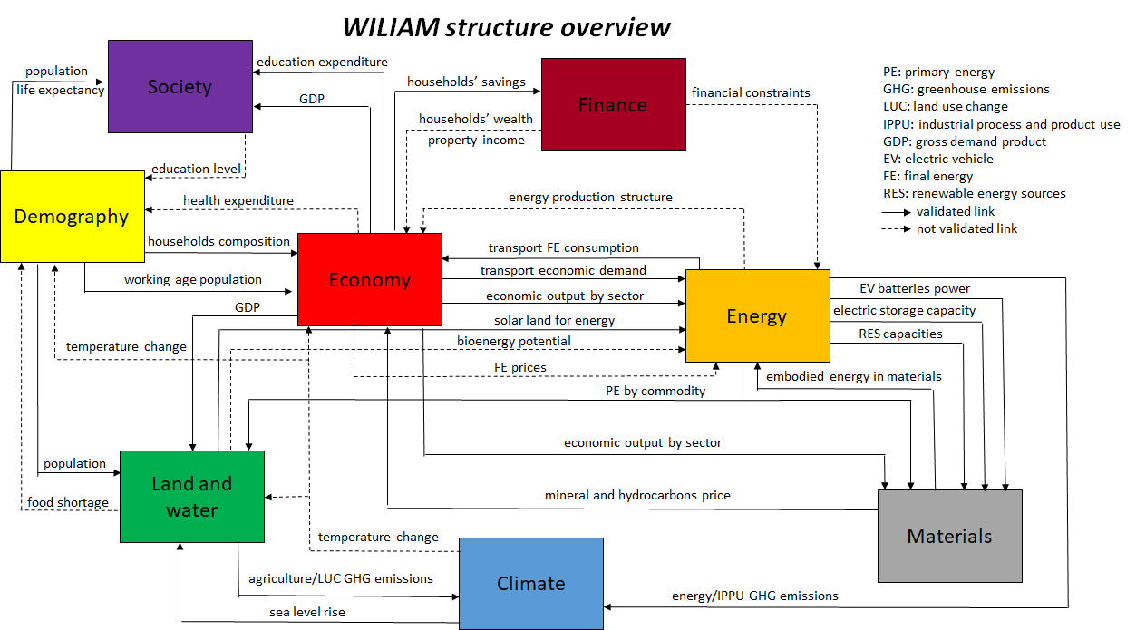

Figure 1: WILIAM simplified structure overview. Main linkages between modules, validated (solid arrows) and not validated links (dashed arrows).

Follow a summary of the main characteristics of WILIAM:

* Detailed geographical coverage: multi-regional world model with 8 global regions and the integration of the 27 EU countries individually for some dimensions.
* Open source.
* Modularity.
* Modules for demography and society, which allow to consider feedbacks such as migration and the effects of climate change on population.
* The economy is represented by a dynamic econometric model covering 35 regions, with detailed representation of consumption (including 60 households’ types), production (based on input-output tables of 62 sectors), government (including collection of taxes + public expenditures), investment, labor, international trade and financial dimensions.
* The economy module is fully integrated with the rest of the modules: changes in the physical bottom-up models (e.g. energy transformation, transport, material extraction) affects the economic model (e.g. production structure, production/consumption/investment decisions) and vice versa.
* Transport: a detailed representation of passenger transport including 11 transport modes, 10 power trains and a portfolio of behavioral policies.
* Energy supply: representation with high detail of the full energy supply-chain through the main refinery, transformation and supply processes.
* Variability of renewables: keeps track of sub-annual time scale effects on annual energy balances depending on the current power system setup of build-up of generation capacities and flexibility capacities (demand-side management, storage, sector coupling, hydrogen and synthetic fuels).
* Computation of the EROI of the full system considering the EROI and material requirements of green technologies, which feedbacks the energy demand.
* Techno-sustainable potentials of renewables considering biophysical, geographical, natural resources and EROI constraints.
* Modules of fossil fuels and metals fully integrated with energy and economy modules. The models are driven by a demand-price mechanism in which a higher price 1) reduces the demand for materials, and 2) triggers investment to increase the material extraction capacity, limited by available resources and increasing depletion rates
* Land-use module including human food, energy and climate interactions, thus allowing endogenizing land-based renewable potentials (solar and bioenergy), considering the agriculture and land related emissions, and the effects of climate change on biophysical variables such as crop yields.
* Water module: main output is water availability based on demand, supply and climate change impacts.
* Climate module converting emissions coming from the other modules in changes in main climate variables, such as mean temperature change and sea level rise.
* Climate change impacts on capital stock, labor productivity and crop yields.
* The improvement in scenario assessment by integrating demand management policies across modules, particularly for passenger transport and diets.
* A rich portfolio of conventional and heterodox policies (CO2 taxes, basic income, behavioral changes, working time reduction, recycling…) aiming at being able to simulate a broad range of narratives, such as Green Growth, Green Deal and Post-growth/Degrowth.

Overall, the result is a new IAM, which in combination with a pluralistic view to assess future policy-action storylines, will very likely offer alternative insights on future transitions.

The model is currently in its final stage of development and hence in this session we will aim at describing its main characteristics and novelties with relation to the literature, as well as its potentialities with advanced preliminary results.

**References**

[1] Capellán-Pérez, I., Blas, I. de, Nieto, J., Castro, C. de, Miguel, L.J., Carpintero, Ó., Mediavilla, M., Lobejón, L.F., Ferreras-Alonso, N., Rodrigo, P., Frechoso, F., Álvarez-Antelo, D., 2020. MEDEAS: a new modeling framework integrating global biophysical and socioeconomic constraints. Energy Environ. Sci. 13, 986–1017. <https://doi.org/10.1039/C9EE02627D>

[2] Hardt, L., O’Neill, D.W., 2017. Ecological Macroeconomic Models: Assessing Current Developments. Ecological Economics 134, 198–211. <https://doi.org/10.1016/j.ecolecon.2016.12.027>

[3] Scrieciu, S., Rezai, A., Mechler, R., 2013. On the economic foundations of green growth discourses: the case of climate change mitigation and macroeconomic dynamics in economic modeling. WENE 2, 251–268. <https://doi.org/10.1002/wene.57>

[4] Capellán-Pérez, I., de Castro, C., Miguel González, L.J., 2019. Dynamic Energy Return on Energy Investment (EROI) and material requirements in scenarios of global transition to renewable energies. Energy Strategy Reviews 26, 100399. <https://doi.org/10.1016/j.esr.2019.100399>

[5] Barlas, Y., 1996. Formal aspects of model validity and validation in system dynamics. System Dynamics Review 12, 183–210. https://doi.org/10.1002/(SICI)1099-1727(199623)12:3<183::AID-SDR103>3.0.CO;2-4

[6] Sterman, J.D., 2000. Business dynamics: systems thinking and modeling for a complex world. Irwin/McGraw-Hill Boston.